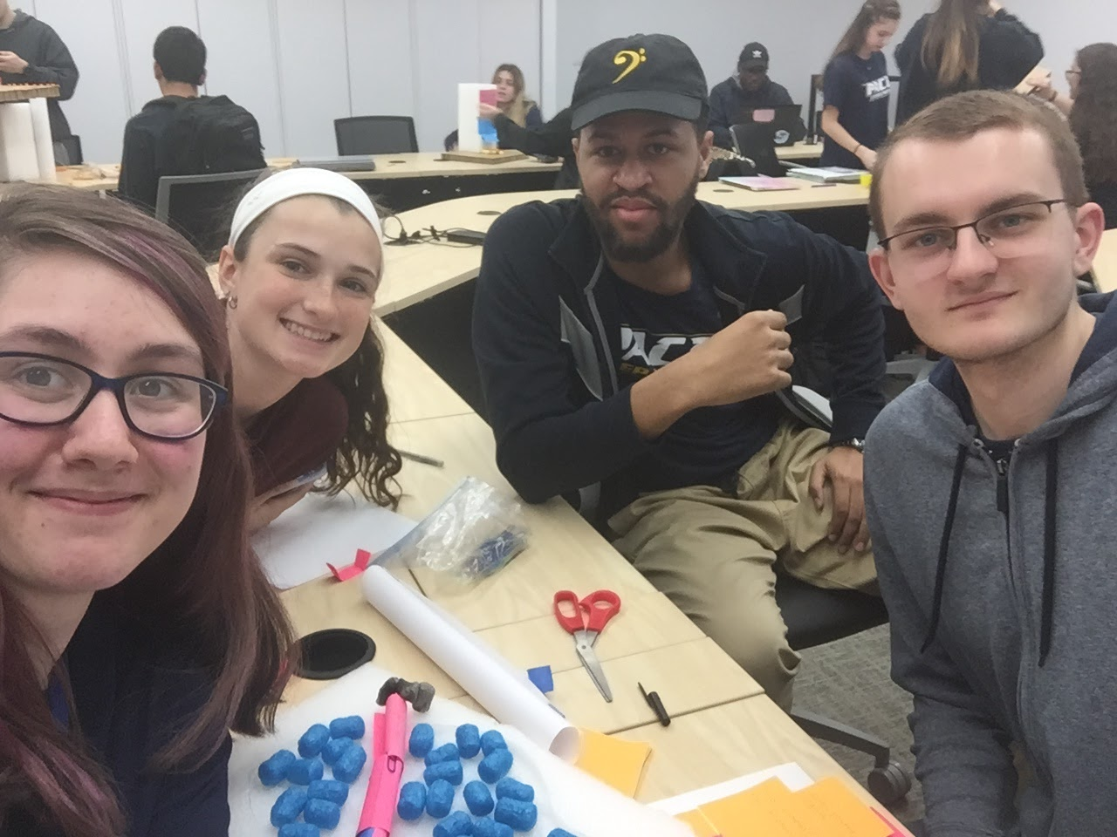

**Team Ying-Yang**

**Assignment: Team Ideation and Prototype Brief – due 4/16**

• Write down the “How might we statement…”

How might we make the pond a more significant thing in the pace experience because students need a way to interact with a central part of the campus

• How many solutions did your team generate?

9 solutions:

* An instagram account for the animals that live in the pond to raise awareness
* New tables/ benches/ facilities
* New birdhouses with webcams to see the birds living there
* Solar powered lights
* Plant more flowers and trees for aesthetics
* Heaters to warm the pond during the winter
* A gazebo on the island in the pond to add to aesthetics
* A walkway with a clear ceiling going under the pond
* A robot to collect trash in the water (Mr. Trash Wheel)

• How did you organize your solutions? Did you identify any categories to organize your solutions by, and what are those categories?

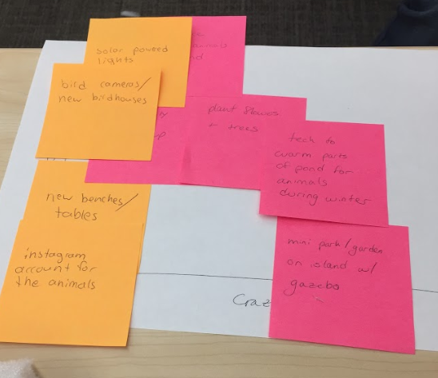

After graphing based on craziness and to what extent the solutions solved the problem at hand we could sort them into general categories depending on what they were proposing including:

* If the idea sought to raise awareness(instagram account and new birdhouses)
* If it involved raising the aesthetic of the pond( more plants and trees,, new benches and tables)
* If it involved new construction (walkway under the pond, more lights)

• What technologies did you consider integrating with your solutions?

* The birdhouses would have webcams for watching the birds from the internet
* The new lights would be solar powered to reduce energy usage
* The water-wheel robot (Mr. Trash Wheel) to clean up the pond would be new technology

• What was your top solution (the one you prototyped)?

* The walkway under the pond (featuring Mr. Trash Wheel)

• Demonstrate your solution visually – sketches, prototype pictures, videos, other visual aids to tell the story of your user/solution; choose images over words

